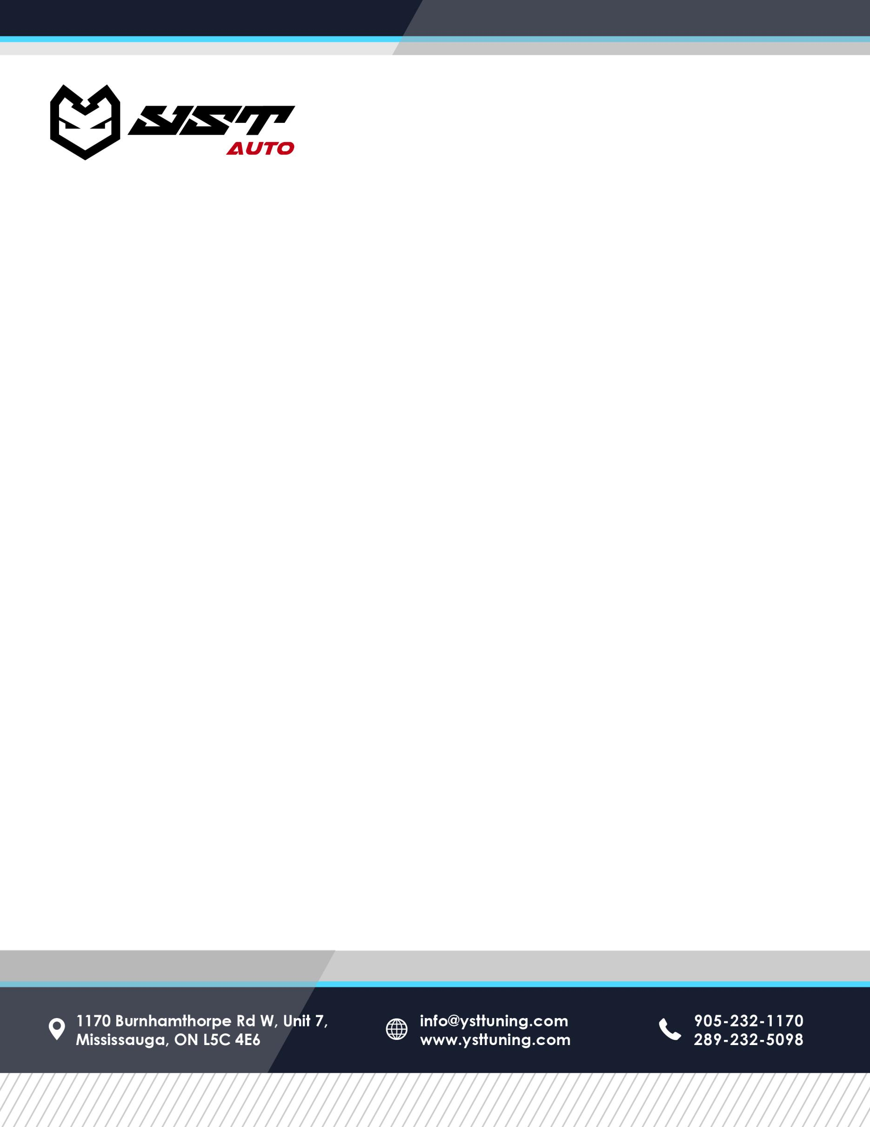

**Limited Lifetime Warranty**

We stand behind our quality and workmanship. YST AUTO BODY offers you **a Limited Lifetime Warranty, (Lease back warranty likewise for leased vehicle)** on all repairs preformed.

This warranty applies to the herein listed customer, and it continues for as long as he/she owns this vehicle. **It is non-transferable and covers labor and materials completed by YST AUTO BODY. Parts and sublets are subject to its original manufacturer’s warranty.**

**This warranty does not cover rust/corrosion or rust/corrosion repairs, normal wear and tear, or damage due to environmental factors** i.e. stone chips, industrial fallout. It does not cover improper maintenance, abnormal use, negligence (including timely reporting of any warrantable repair issues), subsequent damage, fire or other casualties, and does not cover repairs not performed by YST AUTO Body. If repairs are altered by anyone other than staff of YST AUTO BODY this warranty is null and void.

This warranty does not cover any expense for loss of use of your vehicle, any liability to your vehicle or any liability to you or others for bodily injury or property damage. No other warranty is provided or authorized, except for the above written warranty and specific exclusion issued by YST AUTO BODY.

Exclusions: Rust and abrasion, environmental damage, unreasonable use, lack of maintenance and care. The guarantee is void if the vehicle is altered or repaired at any facility other than YST AUTO BODY The guarantee is limited to the cost of the labour and materials to repair defective work only.s No additional costs are covered.

Any other inquiries or concerns please call: 647-479-9999 or [email us.](mailto:info@downtownbodyshop.ca)